Wednesday, May 20, 2026
6:00 PM-8:00 PM | Networking Reception | Location

Thursday, May 21, 2026
8:00 AM-9:00 AM | Breakfast | Location

9:00AM -9:15AM | Opening Remarks | Jamey Harker, President OVBTA
9:15AM-10:15AM | Calculating the Value of a Business Trip | Scott Gillispe, TClara, Advisory Services
10:15AM-11:00AM | ISOS, “Are your travelers prepared for political unrest while traveling” | Matthew Smith, Business Development Director
11:00AM-11:30AM | Cleveland Airport Update | John Hogan, Airport Air Service Development Manager
11:30AM-11:45AM | Spotlight Sponsor | United Airlines
11:45AM-12:00PM | Host Hotel, Ritz Carlton | NNNAME

12:00PM-1:00PM | Lunch | Location

1:00PM-2:00PM | The Collaborative to end Human Trafficking | Carolyn Amy, MA,CCLS,NADD-DD5, Director of Education and Training
2:00PM-2:30PM | AI Pulse | TBD
2:30PM-3:15PM | OVBTA Business Meeting | Jamey Harker & Board
3:15PM-3:45PM | Government Relations Kahootz | Noah McGarr  Bobbi Huber
3:45PM-4:00PM | Raffle | Raffle
This meeting earns XX GTP Credits

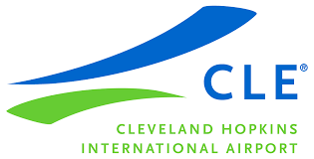
Meeting Sponsors
